**Cross Browser Testing**

|  |  |  |  |
| --- | --- | --- | --- |
| **Browser:** | **Page Being Tested:** | **Screen shot:** | **Comments and Corrective Actions:** |
| Chrome | Home page | **1.1** | Page loaded fine no problems. |
| Login Modal | **1.2** | Page loaded fine no problems. |
| Create course page | **1.3** | Structure of review stars is out of line. Correct (01/05/2017) |
| Learner Home Page | **1.4** | Page loaded fine no problems. |
|
| Safari | Home page | **2.1** | Page loaded fine no problems. |
| Login Modal | **2.2** | Page loaded fine no problems. |
| Create course page | **2.3** | Page loaded fine no problems. |
| Learner Home Page | **2.4** | Page loaded fine no problems. |
| Mozilla Firefox | Home page | **3.1** | Page loaded fine no problems. |
| Login Modal | **3.2** | Page loaded fine no problems. |
| Create course page | **3.3** | Page loaded fine no problems. |
| Learner Home | **3.4** | Page loaded fine no problems. |

**Screen shots:**

**Screen shot 1.1:**



**Screen shot 1.2:**

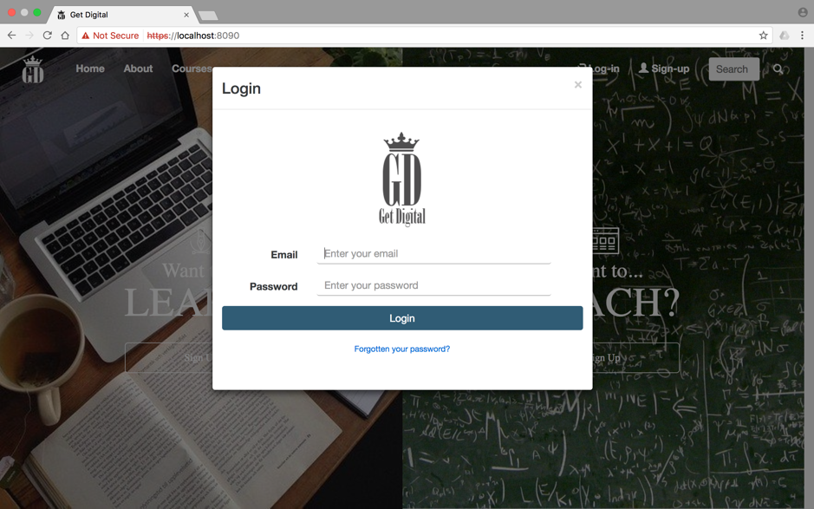

**Screen shot 1.3:**

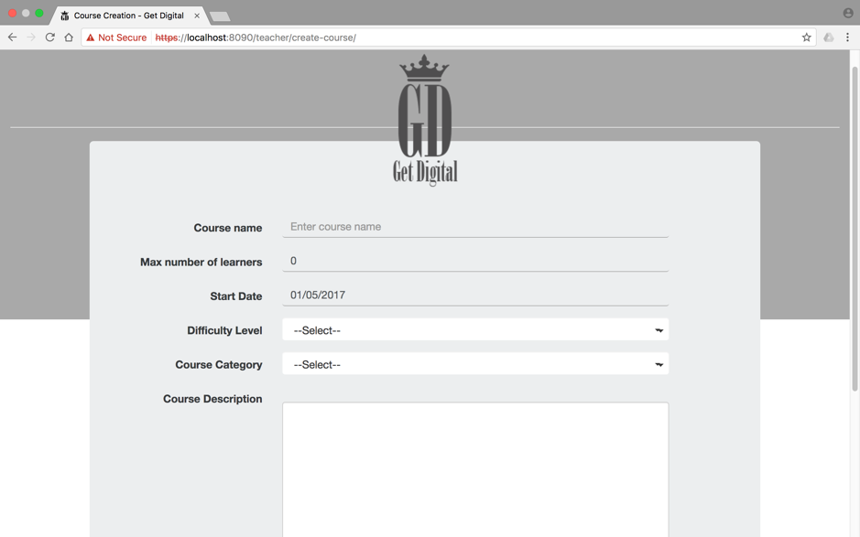

**Screen shot 1.4:**

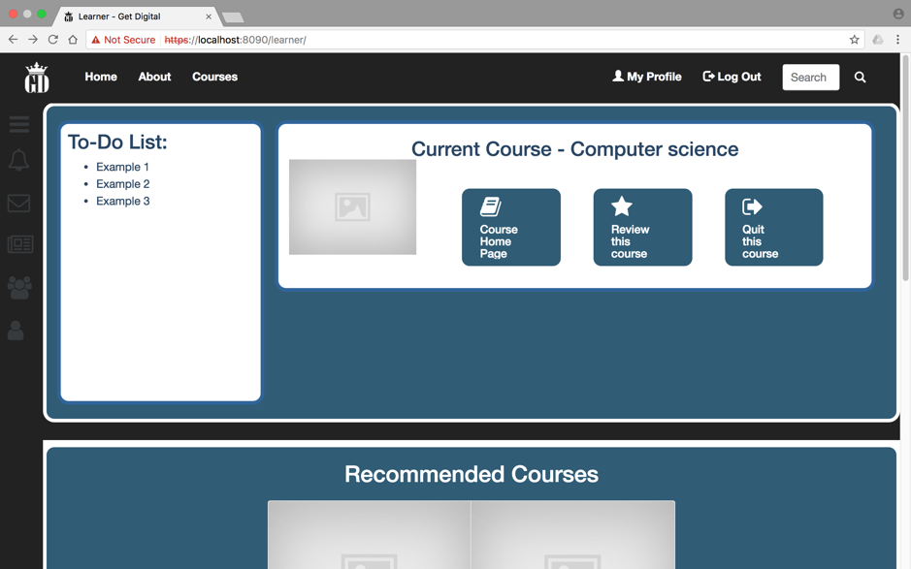

**Screen shot 2.1:**



**Screen shot 2.2:**



**Screen shot 2.3:**



**Screen shot 2.4:**

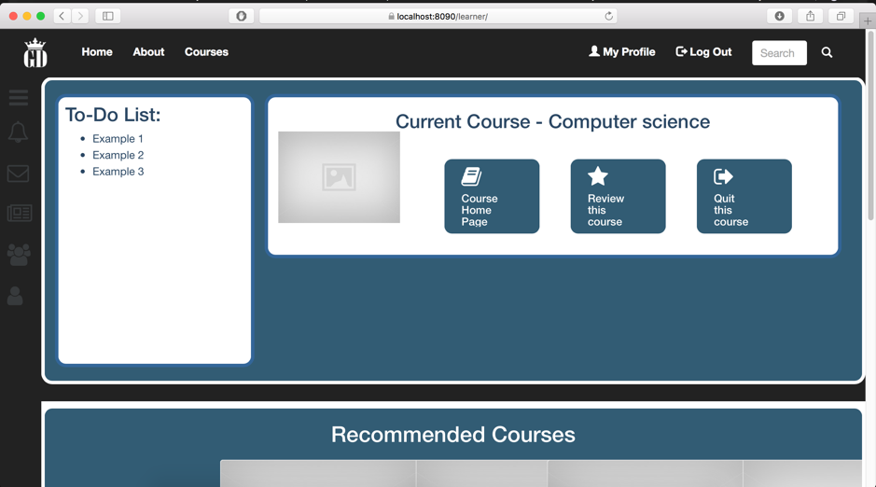

**Screen shot 3.1:**



**Screen shot 3.2:**

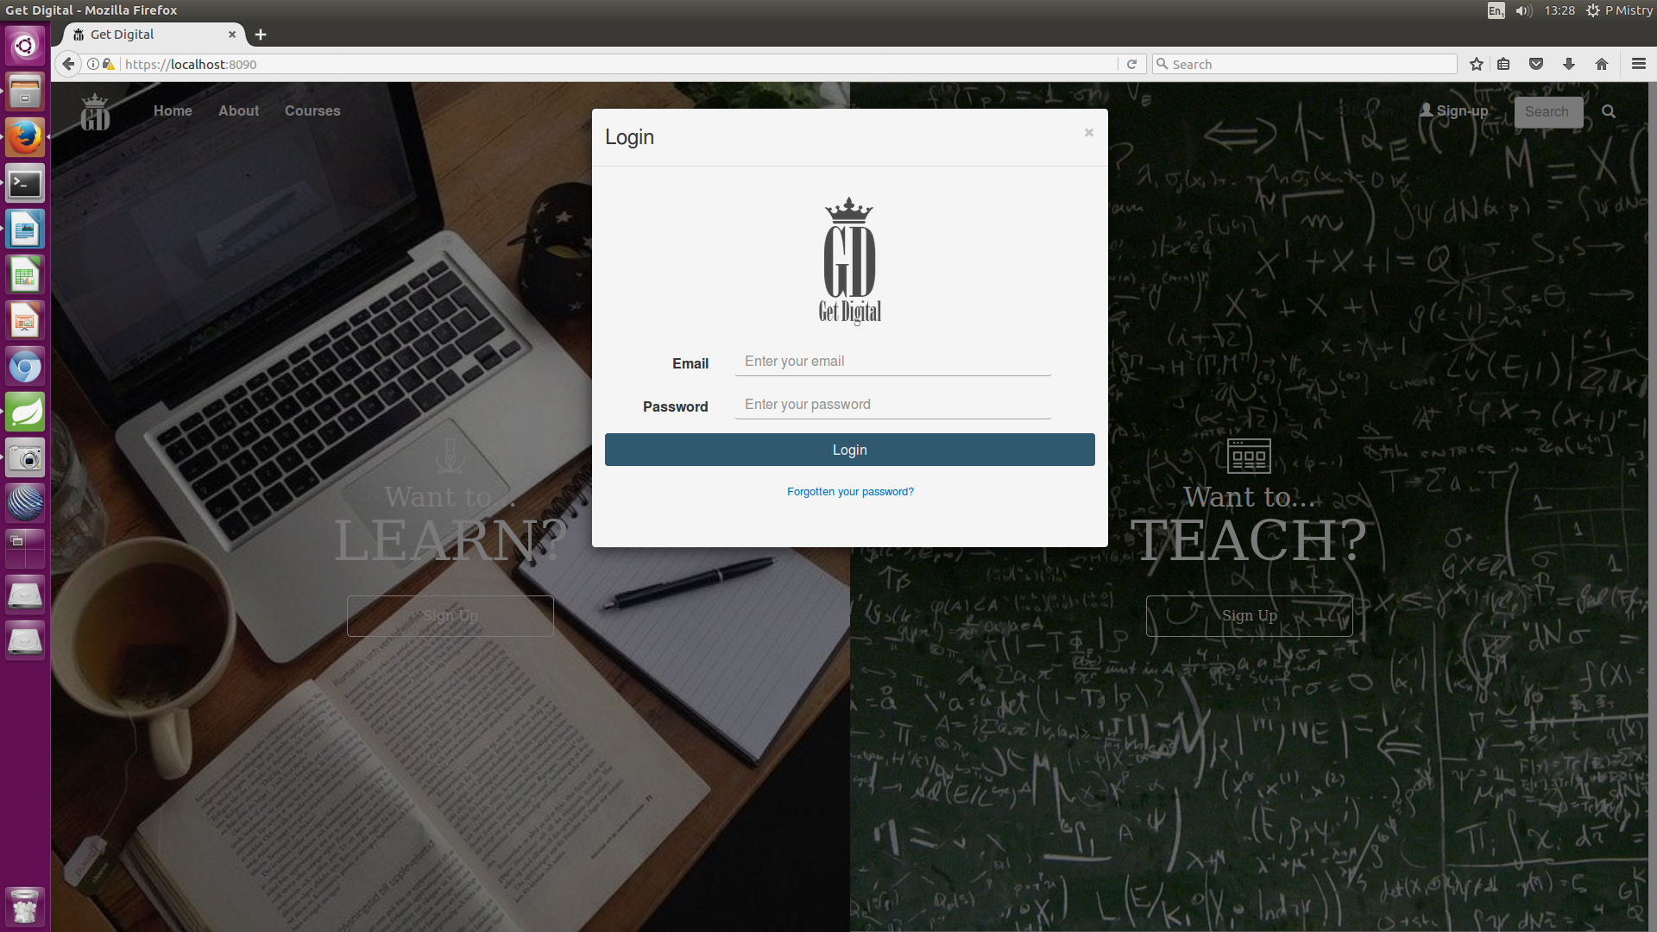

**Screen shot 3.3:**

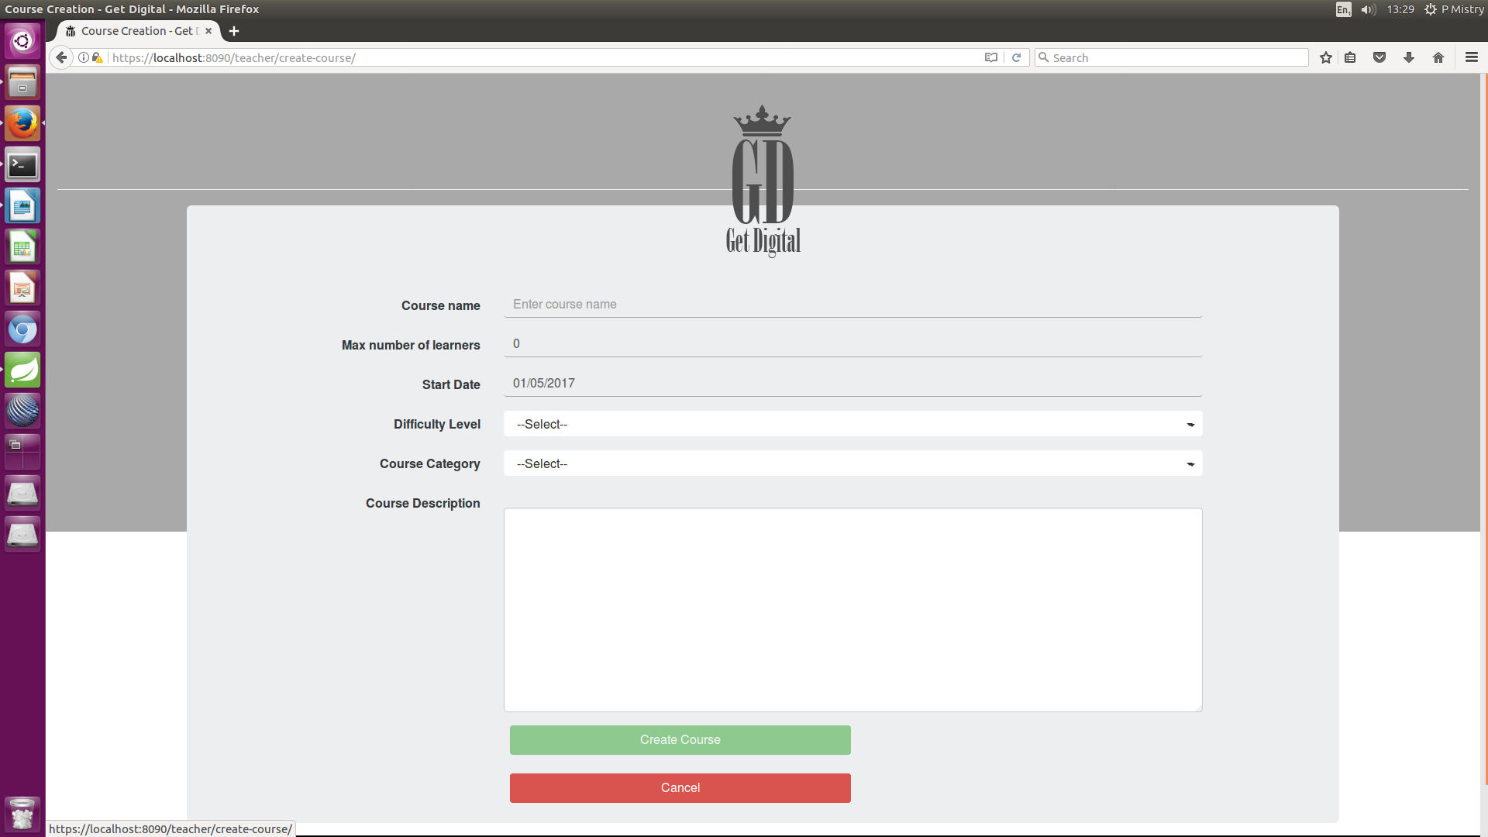

**Screen shot 3.4:**

